Travel Agent profile

Change “Travel Type” TO “Travel Type (select all types which apply)”
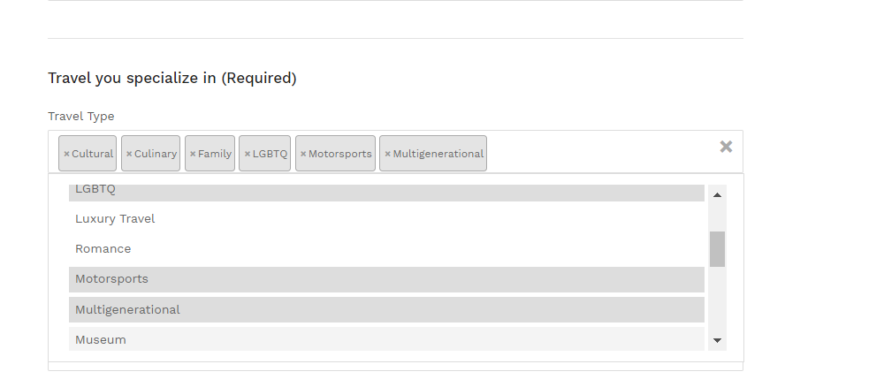
After updating profile as Travel Agent, in Admin it shows it as a ‘Travelller’, should it not be Consumer
